**RANDOM FOREST**

We will use random forest algorithm the get more accurate results. We will use the same features and target as Decision tree and we will use the param_model.

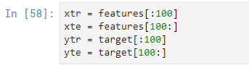

As we said we are applying the algorithm and making a prediction





Let’s look result of the prediction on our targets

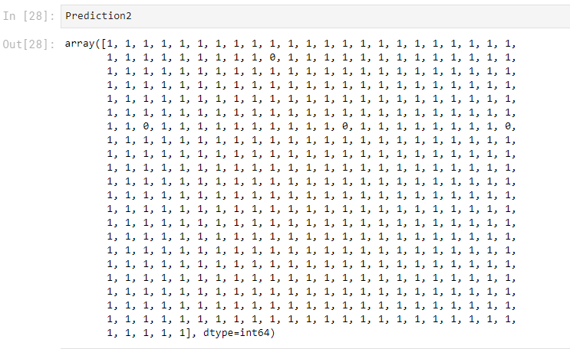

Now let’s look the some results of the prediction on our target(SuccessRate).

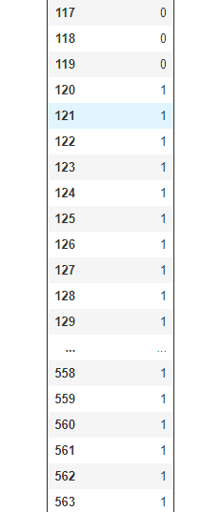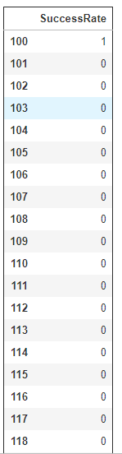 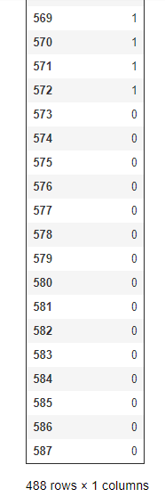

Now let’s check the error ratio and accuracy ratio on our param_model.

